Automation Studio™ offers flexible, intuitive and comprehensive features. Transform textbook theory into a realistic simulation, and increase students’ focus and ability to grasp and apply the concepts studied in class using the following features:

Design Features
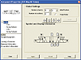
Reproduce systems, and create rich and flexible course material with Automation Studio™ user-friendly design tool;
More info...

Simulation Features
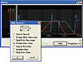
Bring systems to life with Automation Studio™ dynamic and realistic simulation to explain equipment and control operations from the component up to the system level;
More info...

Interface to real equipment
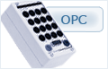
Connect Automation Studio™ to PLCs or hardware equipment.
More info...

