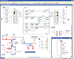

A Dynamic, Realistic, and Visual Simulation for Instant Understanding

Automation Studio™ implements reliable and weighted modeling techniques based, among other, on the Bernouilli's law and gradient method. It allows to reproduce accurately the system behavior in a dynamic and visual way. During simulation, components are animated, and lines and wires are color-coded according to their state. Simulation can then help to explain systems operation, from the component up to the system level, and toassimilate more quickly the theories and concepts studied in class. The simulation paces "Normal", "Slow Motion", "Step by Step", and "Pause" allow to control the simulation speed of selected diagrams.
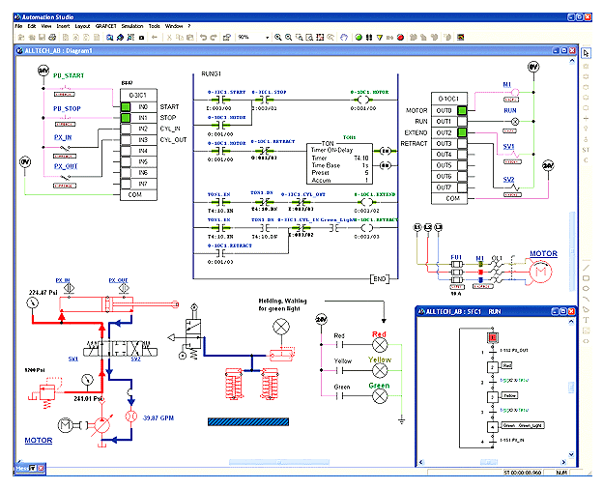

Preconfigured yet Adjustable Simulation Parameters for a Quick Software Handling
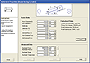

Default simulation parameters have been set for each component of Automation Studio™ so that no initial configuration is required. Simulation parameters such as applied loads, dimensions, angles, as well as advanced parameters including internal leakage, friction, etc, can be easily modified at will. During simulation, you can also control pressure, flow, temperature, voltage, and electric current, as well as kinematic and dynamic variables like position, speed, acceleration, force, and torque.
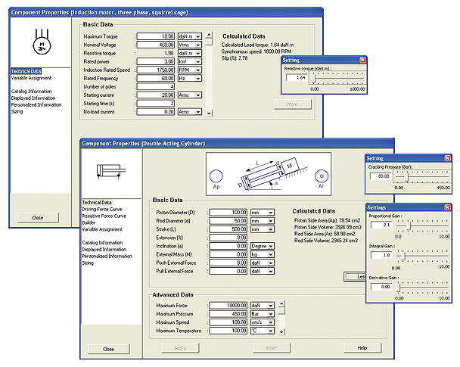

User-Friendly Sizing Module
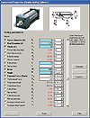
Automation Studio™ provides calculation worksheets specific to each category of pneumatic, hydraulic, and electrical components that include calculation tools necessary for component sizing. When values are modified, their corresponding parameters are automatically recalculated and replaced in the component properties so that changes are considered during simulation. In addition, users can have quick access to applicable equations and parameters definitions. Thus, Automation Studio™ becomes a reference saving time in searching for equations or relevant technical data in external information resources
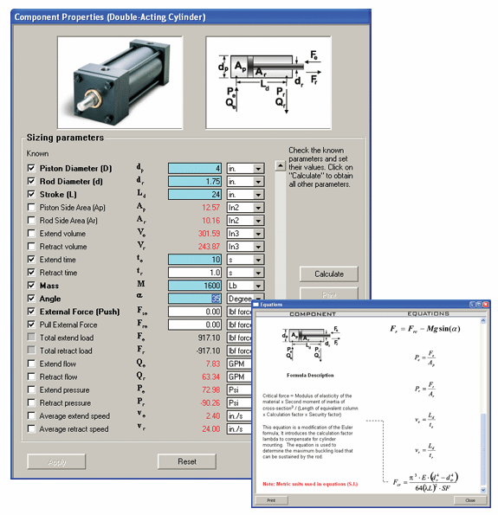

Plotting Simulated Parameters for Basic or In-Depth Analysis
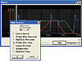
With a simple drag and drop operation, you can plot simulated parameters and variables. The results can be easily exported into a text file, spreadsheet or database application for further analysis.

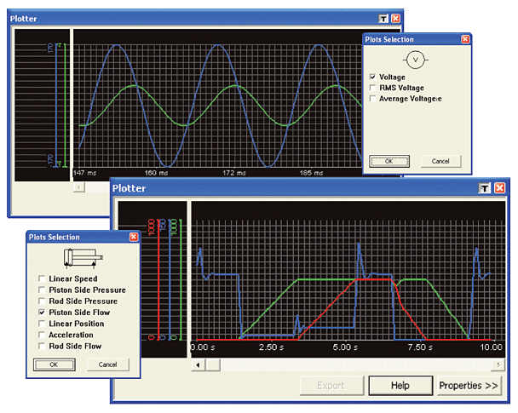

Cross-Section Animations
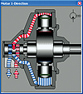
The animated component cross-sections illustrate the internal functioning of components. The animations are synchronized with the circuit simulation
