Shielded air filters有屏蔽的空气过滤器

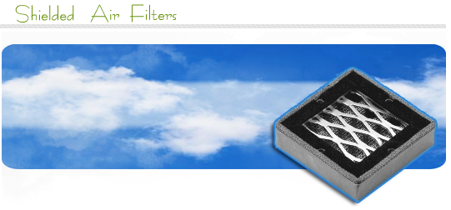

  Shielded air filters有屏蔽的空气滤波器    • Aluminum Mesh铝制网孔  Shielded filter and dust shields perform three functions: they attenuate EMI, they provide for a passage of cooling air, and they filter dust from the air flow.  屏蔽滤波器和防尘罩执行三个功能：它们衰减EMI，它们为冷却空气提供一个通道，它们从气流里过滤灰尘。  Designed for use in industrial environments at low to medium air flow rates, they can be cleaned either by inversion and agitation in a suitable solvent or by air blasting. The filter is comprised of three layers of corrugated aluminum mesh aligned to provide maximum dust trapping effectiveness and minimum resistance to airflow. The filter material is contained in a rigid "C" channel aluminum frame of all welded construction and protected on each side with an expanded metal grid. Electronic filters and dust shields are manufactured to meet the needs of individual applications.  设计用于使用在工业环境里在低到高的气流速率的情形，它们的清洁或者通过翻转及在一个适当的溶剂里摇动，或者通过空气喷射清理。该滤波器是由三层的起皱褶的铝制网孔对齐组成的以提供最大的除尘作用和最小的气流阻力。滤波材料包含在一个“C”形通道全焊接结构的铝制框架里，及在每一边用一个金属网格进行保护。电子滤波器和防尘的制造以适合于工业应用的需要。  For custom requirements, please supply a detailed drawing with the following information:  对于定制的需求，请提供带有下列信息的详细技术图。  Outer dimensions of filter.滤波器的外部尺寸。  Type of gasket required.需求的垫圈类型。  Location and size or type of fixing holes or fasteners (6/32 or 8/32 UNC, preferred).  位置和尺寸或固定孔或紧固件的类型(6/32或8/32 UNC, 首选的).  Use table below as a guide for hole/insert spacings.  对于孔/插入间距使用下表作为一个指导。  Figure 1. Dimensions for Frames Hole positions for Style 1 frames. Supply dimensions A, B, C, & D for non-standard frames. Note: Try to avoid placing holes or fasteners at the corners of the frame.  图1.用于类型1框架的框架孔位置的尺寸。  提供尺寸A,B,C,D用于非标准框架。  备注：设法避免布置孔或紧固件在框架的角落。 | Standard frame sizes标准框架尺寸  Hole positions for frame style like the image on the left.  孔位置：用于如左边图形的框架类型  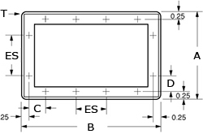  Supply dimensions A, B, C, & D for non-standard frames. So custom sizes are no problem for us.  提供尺寸A,B,C,D用于非标框架。因此定制的尺寸对于我们来说是没有问题的。  Note: Try to avoid placing holes or fasteners at the corners of the frame.  备注：设法避免布置孔或紧固件在框架的角落。  Other products...其它产品  We also produce many more products than honeycomb ventpanels. Below we have a smal list of some products we make. If you want to see al our product click on "see more products" on the bottom of the list.  我们也生产许多的其它产品，下面是我们制造的一些产品的清单。  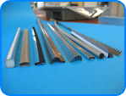  See more products
  Dimensions尺寸  A x B | Fasteners 紧固件Vertical垂直的 |  |  | Fasteners 紧固件Horizontal水平的
  Dimensions尺寸  A x B | NO. | C | SP | No. | D | SP
  4" x 4"  4" x 8"  5" x 5"  5" x 10"  6" x 6"  6" x 12"  7" x 7"  7" x 14"  8" x 8"  8" x 16"  10" x 10"  12" x 12" | 1  1  1  1  2  2  2  2  2  3  3  4 | 1.75"  1.75"  2.25"  2.25"  1.00"  1.00"  1.50"  1.50"  2.00"  0.75"  1.25"  1.25" | -  -  -  -  3.50  3.50  3.50  3.50  3.50  3.00  3.50  3.00 | 1  3  2  3  2  4  2  4  3  5  3  4 | 1.75"  0.75"  0.75"  1.25"  1.00"  1.25"  1.50"  1.50"  0.75"  1.25"  1.25"  1.25" | -  3.00  3.00  3.50  3.50  3.00  3.50  3.50  3.00  3.25  3.50  3.00

