Elektro magnetic shielding电磁屏蔽

Low-frequency magnetic shielding低频磁屏蔽 (MuFerro™ 6800)

We has developed a new material for shielding / screening low frequent magnetic fields. These fields are generated by installations in which high currents flow, for example transformer rooms, power lines, busbar systems and nearby high-voltage cables.
我们发展了一款新材料用于屏蔽/保护低频磁场。这些场的产生由在高电流的装置产生，例如变压器室，电源线，母线系统和在高压电缆附近等。

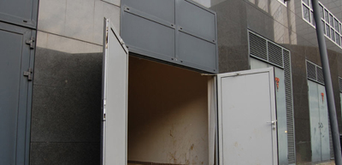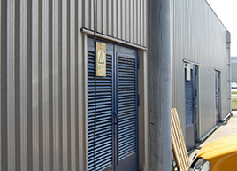

Indoor transformer rooms室内变压器室

Indoor transformer rooms室内变压器室
The frequency of these magnetic fields is typically 50/60 Hz
这些磁场的频率是典型的50/60 Hz
But the MuFerro material is suitable for magnetic shielding in frequency ranges from 10 Hz to 100 KHz.
但MuFerro钼亚铁材料适合于磁屏蔽的频率范围从10 Hz到100 KHz。

Customer Benefits顾客的好处
- Cost-effective solution 有成本效益的解决
- Up to 95% field-strength reduction and more 可达95%或更多的场强减少
- Flexible design 灵活的设计
- Measurement report 测量报告
- 10-year guarantee 10年保障

MuFerro combines permeable and satiety characteristics which makes it extremely suitable for screening low-frequent magnetic fields.
MuFerro钼亚铁结合有渗透和饱和的特性使得它极其适合于屏蔽低频磁场。

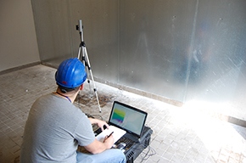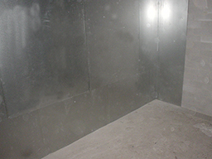

Magnetic field strength measurement MuFerro™ 6800 wall shielding
磁场强度测量 MuFerro钼亚铁墙屏蔽

Why use magnetic shielding/screening?
为什么使用磁屏蔽/保护？

Magnetic fields pose a serious threat to human health and wellbeing. Scientific research has shown that exposure to magnetic fields of > 300nT or 0,003 Gauss increases one's chance of developing leukemia significantly. Moreover there are numerous other health symptoms that are associated with exposure to magnetic fields, e.g. headaches, depression, and insomnia. For this reason many countries have made the recommendation that for working spaces exposure should be < 0.5 μT=500 nT and for public spaces it should be < 0.1 μT=100nT.
磁场对于人类的健康和幸福是一个严重的威胁。科学研究表明暴露到> 300nT or 0,003 Gauss的磁场将增加人们得白血病的机会，这是值得关注的。而且有很多的其它健康症兆与暴露到磁场相关，例如：抑郁，失眠，等。因为这个原因许多国家做出了劝告，对于工作区域暴露应该是 < 0.5 μT=500 nT，及对于公共区域它应该是< 0.1 μT=100nT.
Apart from their negative impact on health, strong magnetic fields can disturb or damage electronics in the direct surroundings of the field. In addition, magnetic fields disturb sensitive measurements in hospitals and laboratories.
除了它们的影响健康以外，在场的直接环境的强磁场能干扰和损害电子设备。另外，磁场干扰敏感度在医院和实验室进行。

Applications应用
- Transformer rooms变压器室 (indoors or outdoors室内或室外)
- Power plants发电厂
- Aluminium melting/production铝溶解/生产
- High-voltage labs 高压实验室
- Enything that creates high magnetic fields (high currents) 其它的产生高磁场的情况（高电流）

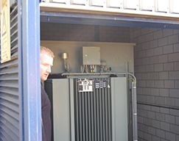
Transformer room变压器室

We can realise magnetic shielding even after the transformer has been placed. For screening whole buildings, or rooms, the shielding material is applied to walls, ceilings and/or floors. This protects both people and electronics.
我们能实现磁场屏蔽即使在变压器被放置以后。对于屏蔽整个建筑。或房间，屏蔽材料被应用到墙，顶棚和/或地板。这个对人和电子设备两者提供保护。

Magnetic-field measurements磁场测量
Before the screening/shielding is put in place a site survey (magnetic field-strenght measurement) can be conducted. We not only measure the magnetic field strength but also locate its probable source. The measurement results are provided in a report.
在屏蔽/保护生效以前在场地将进行实施一个现场勘测（磁场强度测量）。我们不仅测量磁场强度而且定位它的可能场源。测量结果被提交在一个报告里。
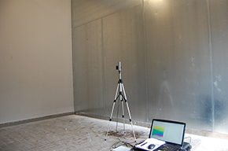
Measuring setup测量装置

Examples of projects项目的例子
Due to space restrictions, one of our customers was forced to create a workplace in a room which had formerly been used as a warehouse and that was located above power transformers. After the magnetic fields were noticed by flickering computer displays, we were asked to carry out a magnetic field measurement. It was found that the magnetic field-strenght was far above the standard referred to above: it was 750nTesla. The magnetic field was reduced by installing an umbrella construction of MuFerro™ 6800. After completion of this project, the magnetic field measured only 80nTesla.

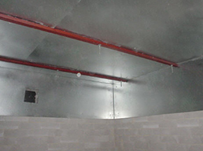
MuFerro™ 6800 ceiling umbrella construction顶棚伞结构

The graph below show the magnetic fields in nano Tesla or 10⁻⁵ Gauss before and after the magnetic shielding was installed.
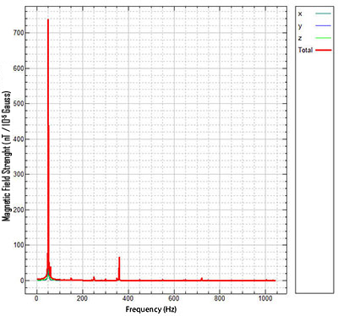
Measurement before placing MuFerro™ 6800 plating
750 nTesla
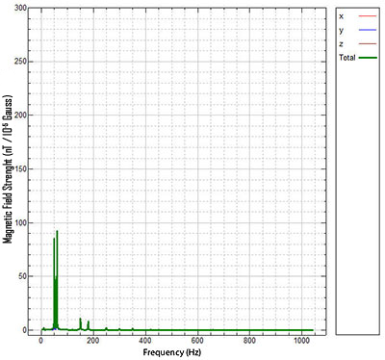
Measurement after placing MuFerro™ 6800 plating
80 nTesla

Several cliants have engaged us to place MuFerro™ 6800 shielding, including:




For more information please download our Mu-Ferro brochure.
Also see "Magnetic shielding for sensors and electronic devices"

