Displays & Windows 9700 Series显示和窗户系列

Cast/Mesh windows铸塑/网孔窗户
For the highest shielding performance a woven microstructure of mesh is bonded between two layers of glass/plastic (stepped window) or a single layer of mesh foil is fixed onto one side of the window with self-adhesive (single window). This can be done by laminating or edge bonding. The windows can be provided with a silver bus bar, a gasket or be supplied with a frame for easy mounting. Windows can optionally be provided with water seal.
对于最高屏蔽性能一个编织微结构的网孔被黏合在两层的玻璃/塑料之间（非连续窗）或一个单层的网孔薄片被固定到窗户的一侧带有自粘（单窗）。这个能通过层压或边缘黏结方法实现。该窗户能提供一个银母线，一个垫圈或提供一个框架为了容易装配。窗户能选择提供水封。

Licht transmission光透射率
Opacity of mesh windows is 64,5%. A lack of available light need not be a concern, since an average pair of sunglasses allows less than 9% light to come through.
网孔窗的暗度是64.5%。一个可用的光需要的不足不是一个担心，自从一个普通的太阳镜对允许小于9%光线通过。

Applications应用
- LCD displays显示器;
- membrane switches薄膜开关,
- Touch screens触摸屏
- Defence / Avionics etc.防卫/航空等等。

Technical details and shielding performance of mesh window
网孔窗的技术细节和屏蔽性能
Material材料 |  | Stainless Steel不锈钢 |  |  |  | Phosphor Bronze磷青铜 |  | Copper铜 |  | Conductive coating导电涂层
Type类型 (wires/inch) |  | 70 | 80 | 100 | 250 | 100 | 250 | 70 | 100 | -
Wire Diameter线径 (mm) |  | 0.076 | 0.050 | 0.050 | 0.035 | 0.097 | 0.035 | 0.076 | 0.050 | -
Nominal Aaperture 标称孔径(mm) |  | 0.287 | 0.267 | 0.204 | 0.067 | 0.157 | 0.067 | 0.287 | 0.204 | -
Light Transmission光透射率 % |  | 62.6 | 71 | 64.5 | 43.5 | 38.2 | 43.5 | 62.6 | 64.5 | 65-95%
Attenuation衰减
Field type场类型 | Frequency频率 | dB | dB | dB | dB | dB | dB | dB | dB | dB
H | 10 kHz | 20 | 21 | 22 | 22 | 22 | 20 | 24 | 22 | -
H | 100 kHz | 21 | 23 | 23 | 22 | 42 | 24 | 39 | 35 | -
H | 1000 kHz | 30 | 33 | 29 | 37 | 61 | 40 | 58 | 54 | -
E | 1 MHz | 90 | 104 | 101 | 114 | 120 | 120 | 105 | 111 | 73
E | 10 MHz | 89 | 86 | 75 | 91 | 110 | 97 | 100 | 99 | 65
E | 100 MHz | 69 | 75 | 68 | 78 | 96 | 91 | 86 | 95 | 64
P | 1 GHz | 66 | 60 | 64 | 75 | 79 | 87 | 66 | 72 | 20
P | 10 GHz | 33 | 32 | 35 | - | 46 | 60 | 34 | 45 | -
See garantee

Faraday cage windows法拉第箱体窗
We also manufacture ready to install Faraday cage windows. These windows guarantee high shielding performance. Faraday cage windows can be manufactured in every dimension.
我们也制造预备安装的法拉第箱体窗户。这些窗户确保高屏蔽性能。法拉第箱体窗户能做成各种尺寸。
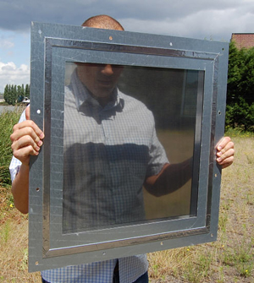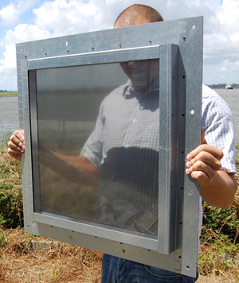
Heavy duty Faraday cage window重载法拉第箱体窗户

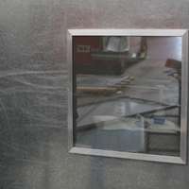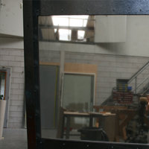
Standard Faraday cage window标准法拉第箱体窗户

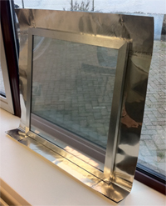
MRI window (Ready to solder用于焊接)

Faraday cage window technical drawing法拉第箱体窗户技术图
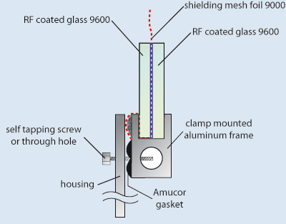

Conductive coating window导电涂层窗户
For small areas a transparent polyester foil with a highly conductive coating is commonly used. The foil is available with self adhesive or can be laminated onto glass, acrylic, polycarbonate or any other flat surface. The light transmission is 65-95%, depending on electrical conductivity (20-5 Ohm/sq). For the best chemical and mechanical durability and transparency the transparent conductive coating is sputtered directly onto glass or polycarbonate. However, a mesh foil window provides higher shielding performance than a coated window.
对于小区域通常使用一个透明的带有高导电涂层的聚酯薄片。该薄片可获得带有自粘或能被叠压到玻璃，丙烯酸塑料，聚碳酸酯或任何其它的平面上。该光透射率是65-95%，依据导电率(20-5 Ohm/sq)。对于最好的化学和机械耐久性和透明度该透明导电涂层被直接喷射到玻璃或聚碳酸酯上。然而，一个网孔薄片窗比一个涂层窗提供了最高的屏蔽性能。

Shielding performance of conductive coating window导电涂层窗的屏蔽性能
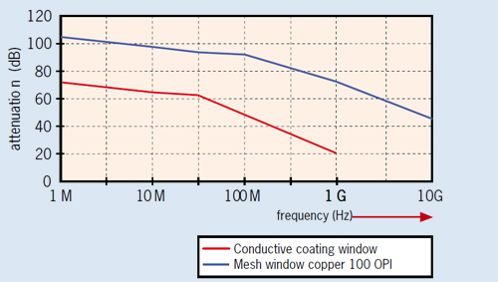

Technical drawing of a conductive coating window导电涂层窗的技术图
