LAN TESTER 300 MHz - EASYLAN

Trust an expert for your LAN certification

ISO 11801
TIA/EIA 568
EN 50173

- Cat 3 to 6 / Class C to E
- Performs required tests up to 300 MHz
- Easy-to-use with Autotest button
- Software for data-records management and reports editions
- The surest choice in an evolving world, always be at the latest Standards level
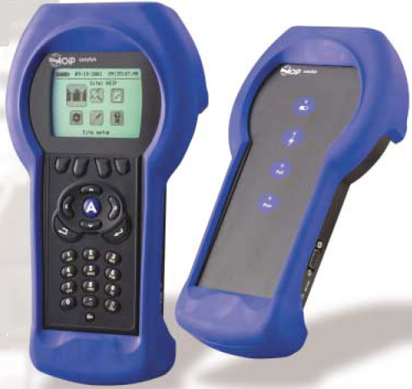
✔ Easylan, the 1st european tester

Do your customers require high level performance for
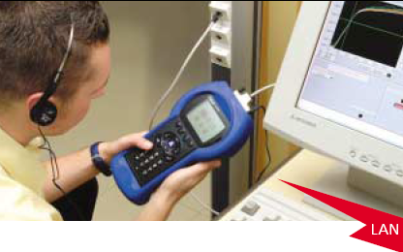
Just one button to certify easily

A short press on the autotest button will trigger automatically all tests. Easylan displays test results as PASS or FAIL.

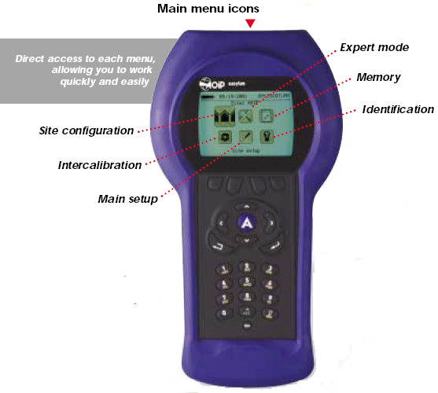
Forget about technique!
The Easylan undertakes it.
It certifies your LAN according to the selected Standard, and tests all parameters required by it. Now, more than ever easy-to-use, spend your time in certifying and not on training.

A tester always at the top of performances
As standards are evolving with performance demands, AOIP guarantees you to be always at the latest standards level by offering you regularly and free of charge updates of the tester and its certification software from our Web sites.

Save time & money
The ultimate operation in the cabling installation is the cabling system’s certification, for which very often the time is counted.
Easylan easy-to-use avoids delay penalties.
Save time and improve team’s coordination using the Talk-set.
- Store up to 1700 autotests.
- Silmultaneous management of 10 sites.
- Multi-language tester, Easylan speaks English, French, German, Italian & Spanish

certification? AOIP has the solution

Management software
Easysoft delivered with the Tester Easylan enables to download results performed on site, via the serial RS link.
Test reports can be then printed in a short or detailed form.
Test Results report
Color Graphical display

High quality reports
Provide your customer with high quality and professional test reports. The Easysoft organizes professionally all test results facilitating the analyze of cabling quality.
The graphical representation includes curves of test data together with the headroom vs. limits according to the selected Standard.
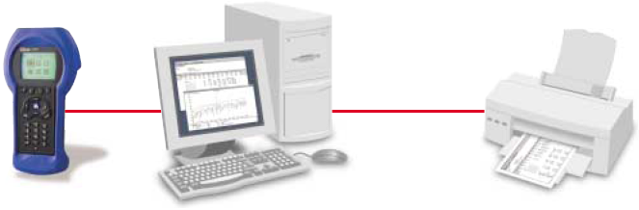
Technical specifications
Bandwidth
1 to 300 MHz
TIA/EIA 568 Level III accuracy
Test parameters
Wire map : Identify miswires
Length : Accuracy ± 0.3 m
Propagation delay : Accuracy ± 10 ns
Delay skew
DC loop resistance : Accuracy ± 0.5 Ω
NEXT, PSNEXT ELFEXT, PSELFEXT, ACR, PSACR
Return Loss
Attenuation : According to the selected standard
TDR function
Spurious voltage : U < 2 V
Test standards
USA standard : TIA/EIA 568 category 3, 5, 5E and 6
International standard : ISO/IEC 11801 Class C, D, E, IEEE 802.3-.5
European standard : EN 50173 Class C, D, E
Other : AZ/NZS 3080
Cabling system
Copper cabling: Coaxial, UTP, FTP, STP, SCTP, SFTP and SSTP.
Fiber’s LAN: multimode and singlemode
Networks
Easylan certifies following networks:
10BASE-2, 10BASE-5, 10BASE-T, 100BASE-TX, 1000BASE-T, Ethernet, 4Mb-
16Mb TOKEN-RING,ATM155/51.

General characteristics
Display
LCD graphical display 192x128 pixels.
Back light function.
Menu in 5 languages: English, French, German, Italian and Spanish.
Ports
RS232 serial port SUBD 9.
Talk set interface with stereo jack.
Power source
Removable, rechargeable NiMH battery pack.
Charging time: 3 hours.
Battery life: 10 hours operation.
Physical presentation
Dimensions: 260x166x60 mm (tester - remote unit).
Weight: 1.1 kg/4.6 kg (complete set).
ABS casing with protection sheath.
Operating range
0°C to 50°C and 20 to 80% RH without condensation.

Other features
Memory capacity 1700 autotests.
Simultaneous management of 10 sites.
Built-in intercom.
The above characteristics are subject to modification.

Ordering information
LAN TESTER 300 MHz «Easylan»
Delivered in standard:
• One tester Easylan
• One remote unit
• Two AC power adapters (230V)
• Two Universal Permanent link cables
• Two female RJ45 adapters
• One inter-calibration cable
• One RS232 serial link
• « Easysoft » management software
• User’s manual
The complete set delivered in a soft carrying case
- ACCESSORIES AND OPTIONS
• Removable battery pack AN6010
• Talk set kit ATL305
• Car lighter DC power adapter ATL306
• Two RJ45 measurement cable PL1
• RJ45 female adapter ATL303
• BNC adapter ATL304
• Inter-calibration cable ATL302
For the following accessories, please contact us :
• Cat6/ClassE RJ45 measurement cables
• Optical receiver 850 to 1550 nm
• Source / multimode CF 850 nm
• Source / multimode CF 1300 nm
• Laser source / singlemode CF 1310 nm
• Laser source / singlemode CF 1550 nm
• Optical link adapters : ST/SC/FC/MTJR
• Test report

