VISULOG Traceability , Monitoring and Acquisition Management Software
Acquisition
Control
Monitoring
Traceability

VISULOG: traceability , monitoring and acquisition management software
VISULOG is a wonderful and simple tool to complete the AOIP's data logging systems range

It allows acquisition on a computer on more than 5000 channels, and provides calculation channels, for statistics and advanced calculation as, for instance, needed in ovens mapping
Users can define result files, audit trails, can manage the acquisitions.

Build your own screen
Measurements can be displayed list of results, curves, bargraphes and high definition mimic diagrams Pictures or schematic of you installation can be set as a background of the screen, then you can place curves, channels values close the real points

All the results can be exported to spread sheets as excel other software. Alarms can be also defined by the user. These alarms can generate pop up , emails to one or several users

VISULOG and 21CFRPart 11 (FDA Standard)
The visulog software can be configured to fulfil all the 21CFR PART11 requests.

Security management
Login; passwords
3 levels: administrator, super user
User
Each level with special rights

Passwords wil automatically expire unless renewed within a configurable time

User accounts are disabled after a number of failed login attempt and failure are logged into the audit trail

Results files are stored in a Visulog format *.vgc

Alarms validation are submit to signatures
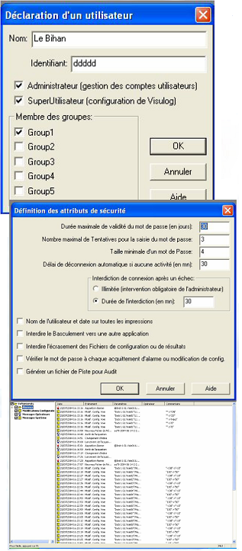
Audit trail:
all the events are recorded in a protected file:
connections, disconnections, alarms appearance alarm clearance, configuration modifications result readings,….

Please do not hesitate to contact AOIP to ask for our "white paper", explaining step by step the accordance of VISULOG to the FDA 21 CFR PART 11 requirements, regarding data saving, access restrictions, and audit trail

Sensors Calibration
Each sensor can be calibrated against a standard. All the corrections can be integrated into the datalogging system.

Autoclave validation

Thanks to the calibration facility, autoclave validation can be performed with the Visulog software:

Process description:
- Pre calibration of the temperature sensor, adjustment into the data-logging system, before the validation.
- Autoclave validation
- Post calibration of the thermal sensors

MONITORING: monitoring of chambers in a pharmaceutical/medical installation in order to verify the nondrift of chambers and to grant the traceability.
Mapping of thermal chamber, climatic chambers and storage room
Visulog can perform online the mapping of a chamber or a storage room.
This allows to define precisely the characteristics fo the room in terms of stability, homogeneity, and thermal differences.

Storage room
In case of storage, according to the specification of the stored products, it is important to know the temperature difference, and the global behaviour of the room.
Once the sensor are placed; it can also help to perform the real time monitoring on the storage room on the supervisor desktop

Climatic and thermostatic chambers
Visulog mapping facilities will perform all the necessary treatments according the standard NF X15-140:
For each sensor and between all te sensors, calculation of stability, homogeneity, maximum, minimum, mean, standard deviation.
Deviation to the setpoint, and deviation to the indicator will be also taken into account.
The Visulog mapping program, is already established for chambers, with volume below 2m3 and between 2 m3 and 20m3.
Mapping of climatic chambers requires use of humidity sensor. At the end of the test a report can be edited.
Of course all data are saved inot the computer.
Test report (example)
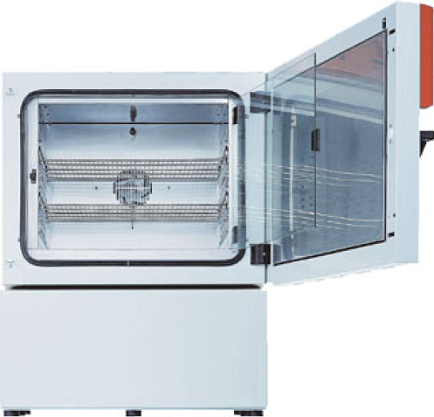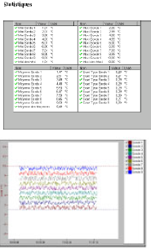

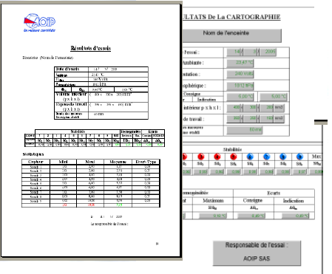

Our complete solution for data acquisition
Datastorage solution from 1 to 300 inputs
Single input with wire or radiofrequency transmission
Video recorder
Modular and stand alone systems

Our solutions for calibration

Dry blocks and ovens
Calibrators for your process maintenace
Pressure calibrators
Standard probes
Temperature sensors

