BCP-515 Broadband Current Probe Data

- Numeric Data
Transfer Impedance Factor Model: BCP-515
Frequency | Transfer Impedance (dB ohms)
1 MHz | -14.50
1.2 MHz | -12.94
1.4 MHz | -11.64
1.6 MHz | -10.46
1.8 MHz | -9.43
2 MHz | -8.57
2.5 MHz | -6.56
3 MHz | -5.00
3.5 MHz | -3.70
4 MHz | -2.57
5 MHz | -0.53
6 MHz | 1.03
7 MHz | 2.37
8 MHz | 3.50
9 MHz | 4.63
10 MHz | 5.53
12 MHz | 7.13
14 MHz | 8.37
16 MHz | 9.43
18 MHz | 10.30
20 MHz | 11.06
30 MHz | 13.27
40 MHz | 13.97
50 MHz | 14.73
100 MHz | 15.94
200 MHz | 16.70
300 MHz | 17.90
400 MHz | 18.50
Conversion Formulas: dBuA = dBuV - dB ohms + Cable Loss

- Transfer Impedance Graph
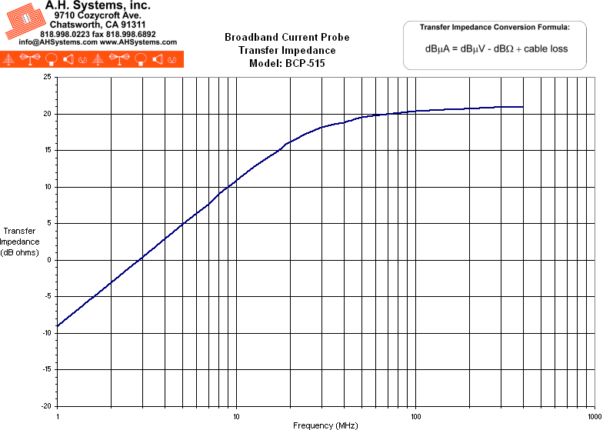
- Product Datasheet (281Kb)
- Operation Manual (198Kb)

