ICP-521 Injection Current Probe Data

- Insertion Loss Graph
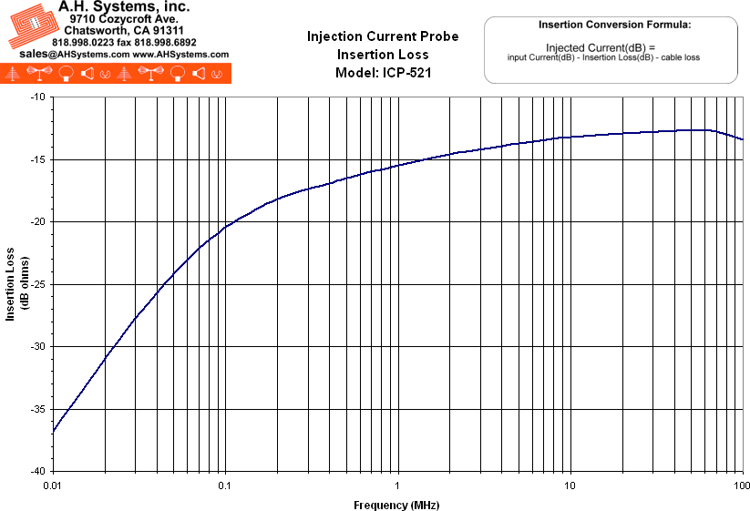
- Numeric Data
Typical Probe Data Model: ICP-521
Frequency | Transfer Impedance (dB ohms) | Insertion Loss (dB)
10 KHz | 0.1 | -33.0
15 KHz | 3.4 | -29.7
20 KHz | 5.8 | -27.4
25 KHz | 7.5 | -25.9
30 KHz | 8.8 | -24.6
35 KHz | 9.8 | -23.7
40 KHz | 10.7 | -22.8
45 KHz | 11.4 | -22.2
50 KHz | 11.9 | -21.7
60 KHz | 12.8 | -20.8
70 KHz | 13.4 | -20.2
80 KHz | 13.9 | -19.8
90 KHz | 14.3 | -19.4
100 KHz | 14.7 | -18.6
150 KHz | 15.6 | -17.4
200 KHz | 16.2 | -17.0
300 KHz | 16.9 | -16.2
400 KHz | 17.3 | -15.7
500 KHz | 17.7 | -15.4
1 MHz | 18.8 | -14.4
2 MHz | 19.7 | -13.9
5 MHz | 20.6 | -13.1
10 MHz | 21.1 | -12.8
20 MHz | 21.4 | -12.8
50 MHz | 21.7 | -13.0
70 MHz | 21.5 | -13.0
100 MHz | 21.5 | -13.6
When injecting current:
Injection current (dB) = Input current (dB) - Insertion loss (dB) - Cable loss
Maximum power rating : 100 Watts for 30 minutes
Do not handle injection probe while testing is in progress.
Hazardous voltages may be present

- Product Datasheet (237Kb)
- Operation Manual (467Kb)

