ICP-522 Injection Current Probe Data

- Insertion Loss Graph
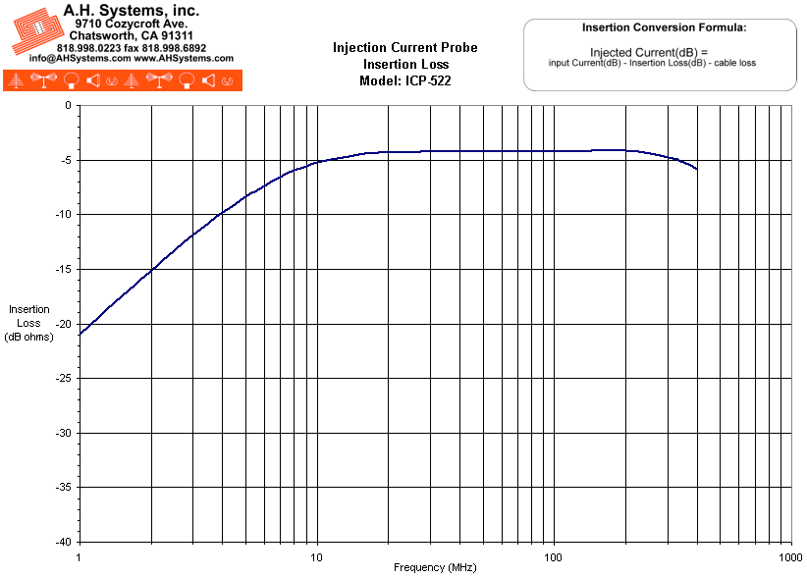
- Numeric Data
Typical Probe Data Model: ICP-522
Frequency (MHz) | Transfer Impedance (dB ohms) | Insertion Loss (dB)
1.0 | 12 | -21.7
1.2 | 13.6 | -20.2
1.4 | 14.9 | -18.8
1.6 | 16 | -17.7
1.8 | 17 | -16.7
2.0 | 18 | -15.7
2.5 | 19.9 | -13.8
3.0 | 21.4 | -12.3
3.5 | 22.7 | -11
4.0 | 23.8 | -10
4.5 | 24.7 | -9.1
5.0 | 25.6 | -8.4
6.0 | 26.9 | -7.3
7.0 | 28 | -6.5
8.0 | 28.9 | -5.9
9.0 | 29.6 | -5.5
10 | 30.1 | -5.2
15 | 31.7 | -4.5
20 | 32.2 | -4.3
50 | 32.1 | -4.2
100 | 32.5 | -4.2
200 | 32.6 | -4.2
300 | 32.4 | -4.8
350 | 31.9 | -5.2
400 | 31.7 | -5.8
When injecting current:
Injection current (dB) = Input current (dB) - Insertion loss (dB) - Cable loss
Maximum power rating : 100 Watts for 30 minutes
Do not handle injection probe while testing is in progress.
Hazardous voltages may be present

- Product Datasheet (253Kb)
- Operation Manual (467Kb)

