ICP-523 Injection Current Probe Data

- Insertion Loss Graph
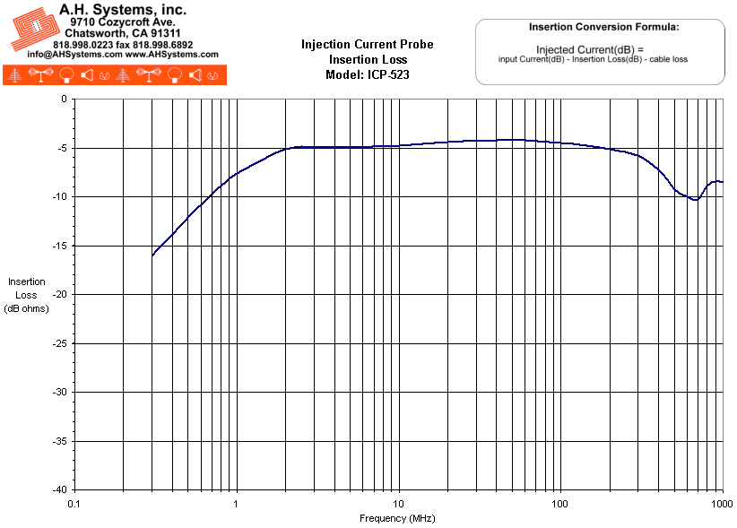
- Numeric Data
Model: ICP-523
Frequency | Transfer Impedance (dB ohms) | Insertion Loss (dB)
300 KHz | 18.1 | -16.1
350 KHz | 19.3 | -14.9
400 KHz | 20.5 | -13.8
450 KHz | 21.4 | -12.9
500 KHz | 22.2 | -12.1
600 KHz | 23.6 | -10.8
700 KHz | 24.8 | -9.7
800 KHz | 25.8 | -8.9
900 KHz | 26.7 | -8.2
1 MHz | 27.6 | -7.6
2 MHz | 31 | -5.2
3 MHz | 31.6 | -4.9
4 MHz | 31.7 | -4.9
5 MHz | 31.8 | -5.0
10 MHz | 32.1 | -4.8
20 MHz | 32.6 | -4.4
50 MHz | 33.0 | -4.2
100 MHz | 33.1 | -4.5
200 MHz | 32.1 | -5.1
300 MHz | 30.4 | -5.8
400 MHz | 28.1 | -7.3
500 MHz | 27.2 | -9.2
600 MHz | 28.1 | -9.9
700 MHz | 27.9 | -9.9
800 MHz | 31.1 | -9.1
900 MHz | 30.5 | -8.6
1000 MHz | 24.4 | -8.5

- Product Datasheet (254Kb)
- Operation Manual (467Kb)

