FCC-3 Tuned Dipole Antenna Data

More Information

- Typical Antenna Factor Plot - 3m
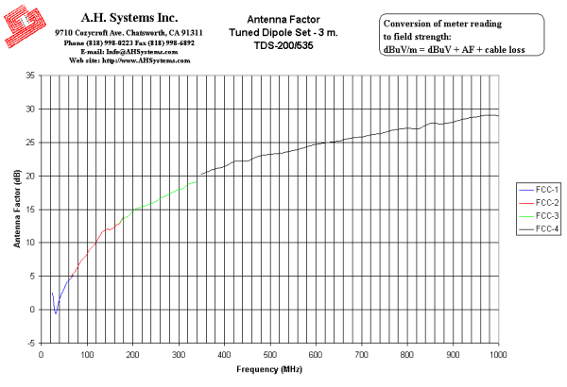
Innovation, Quality, and Performance
- Typical Antenna Factor Plot - 10m
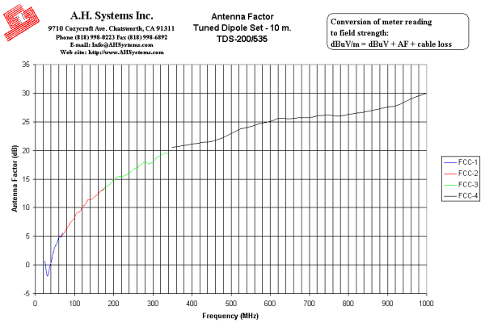
Innovation, Quality, and Performance
- Typical VSWR
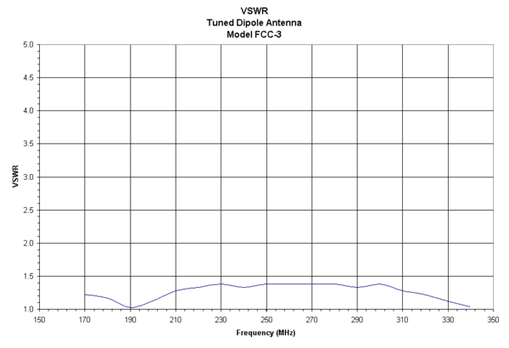
Innovation, Quality, and Performance

- Numeric Data
FCC-3 Tuned Dipole Antenna Data
3 Meter | 10 Meter
Antenna Page | VSWR Graph | AF Graph
3 Meter Antenna Factor
Frequency (MHz) | Element Length (L/2-in.) | Antenna Factor (dB/m) | Gain (dBi)
170 | 16 1/8 | 12.9 | 2.0
180 | 15 3/16 | 13.6 | 1.8
190 | 14 5/16 | 14 | 1.8
200 | 13 5/8 | 14.8 | 1.5
210 | 12 7/8 | 15.1 | 1.6
220 | 12 1/4 | 15.3 | 1.8
230 | 11 9/16 | 15.6 | 1.9
240 | 11 1/8 | 15.8 | 2.1
250 | 10 5/8 | 16.2 | 2.0
260 | 10 1/4 | 16.6 | 1.9
270 | 9 15/16 | 16.9 | 2.0
280 | 9 11/16 | 17.3 | 1.9
290 | 9 3/16 | 17.6 | 1.9
300 | 8 3/4 | 17.9 | 1.9
310 | 8 5/16 | 18.1 | 2.0
320 | 8 | 18.7 | 1.6
330 | 7 13/16 | 18.9 | 1.7
340 | 7 11/16 | 19.1 | 1.8

10 Meter Antenna Factor
Frequency (MHz) | Element Length (L/2-in.) | Antenna Factor (dB/m) | Gain (dBi)
170 | 16 1/8 | 12.9 | 2.0
180 | 15 3/16 | 13.5 | 1.9
190 | 14 5/16 | 14.1 | 1.7
200 | 13 5/8 | 14.9 | 1.4
210 | 12 7/8 | 15.3 | 1.4
220 | 12 1/4 | 15.4 | 1.7
230 | 11 9/16 | 15.7 | 1.8
240 | 11 1/8 | 16 | 1.9
250 | 10 5/8 | 16.7 | 1.5
260 | 10 1/4 | 16.9 | 1.6
270 | 9 15/16 | 17.5 | 1.4
280 | 9 11/16 | 17.9 | 1.3
290 | 9 3/16 | 17.6 | 1.9
300 | 8 3/4 | 18 | 1.8
310 | 8 5/16 | 18.8 | 1.3
320 | 8 | 19 | 1.3
330 | 7 13/16 | 19.5 | 1.1
340 | 7 11/16 | 19.5 | 1.4

