SAS-530H Broadband Dipole Data宽带偶极子天线数据

More Information
- Typical Antenna Factor Plot
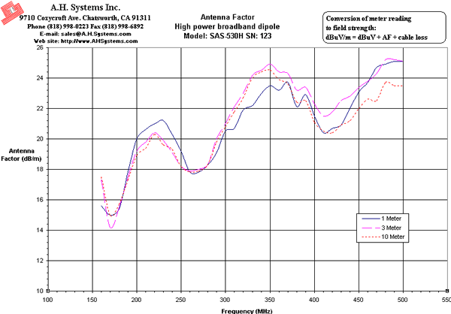
Innovation, Quality, and Performance
- Numeric Data(80Kb)

